AstraZeneca Horizon Place Help Document:

Ordering Within EBSCO Information MarketPlace

Step 1: Copy and Paste the URL below in your Web browser’s address bar (example Internet Explorer) https://www.ebscomarketplace.com/uk/default.asp?customercode=azuk

Step 2: After creating a user account (See help document Creating a User Account)
- Enter your login information
- Click the Login button

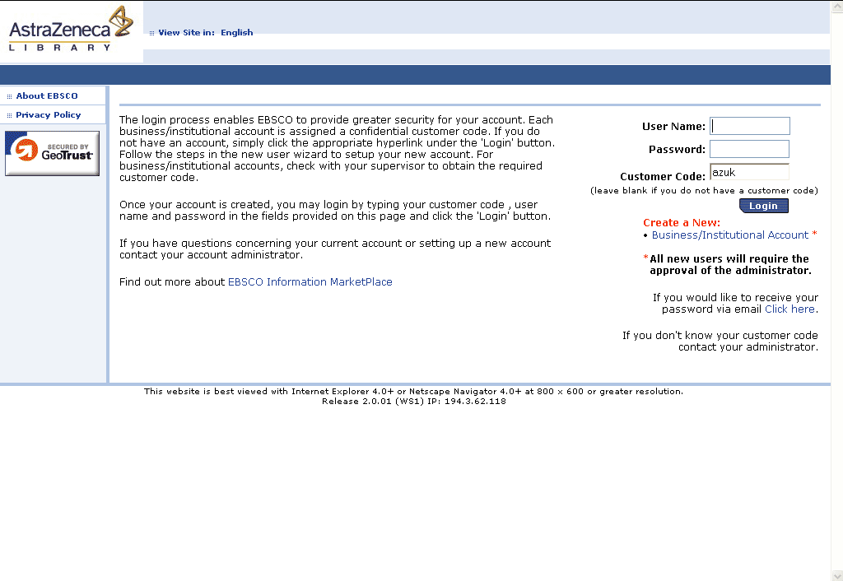

Step 3: Search for titles of interest
- Click the Magazines/Journals Tab to search for titles of interest or the Advanced Search link
- Click on Magazine Search
- Enter keywords within the title field and select either “Exact start” (default option) or “Contains”
- You can also search by EBSCO Title Number or ISSN
- Click the Search button to perform the search

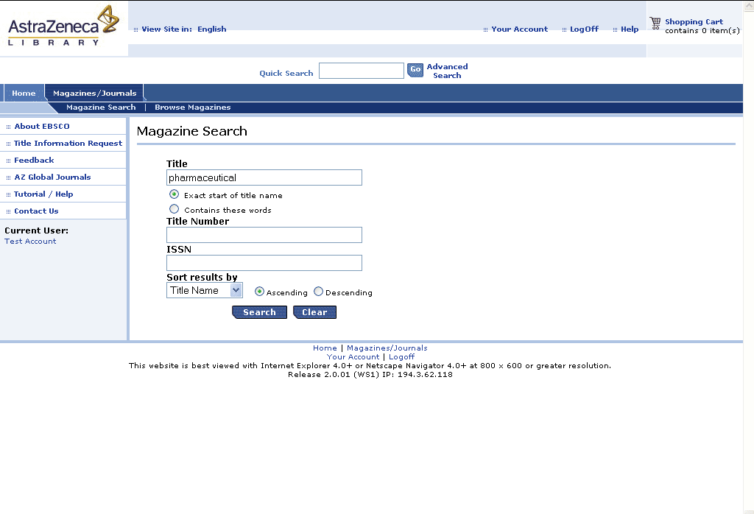

Step 4: Click title within search results to view title details
- Click the Title Name link to view title details

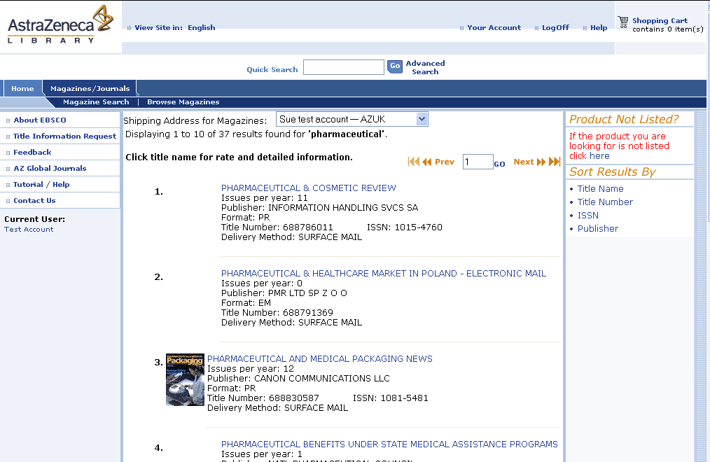

Step 5A: Add to Shopping Cart – Example of NEW Subscription
- After selecting New Subscription, click the Add to Shopping Cart button
- Once you have placed your items in the shopping cart, you need to review the cart.

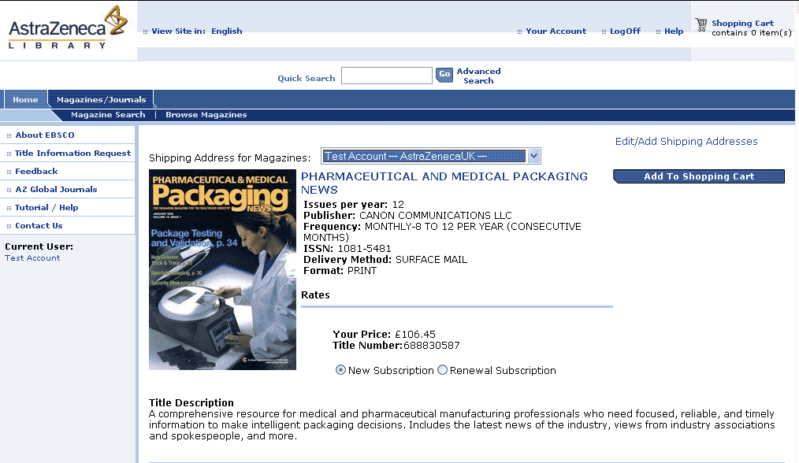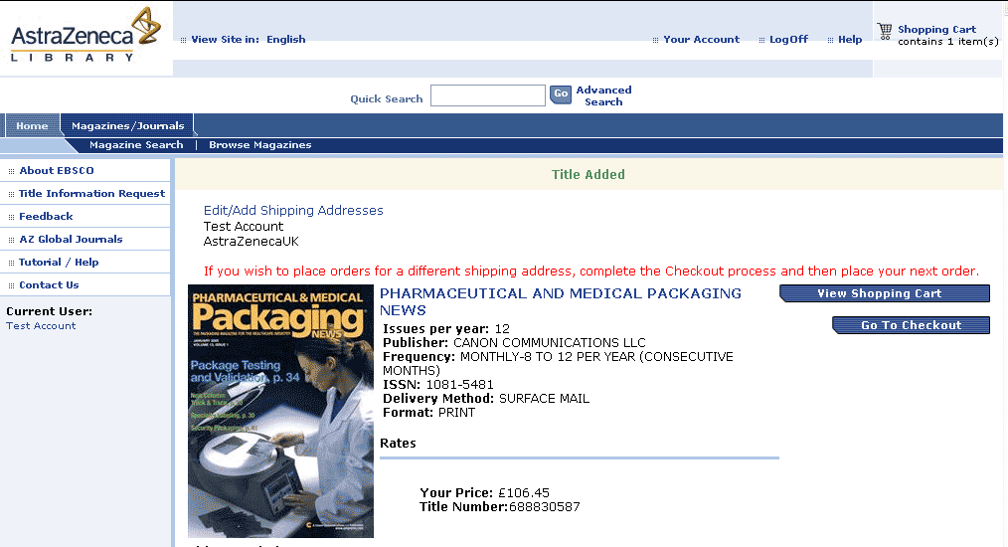
Select New Subscription
and Click Add to Shopping Cart.
Click View Shopping Cart to review items.

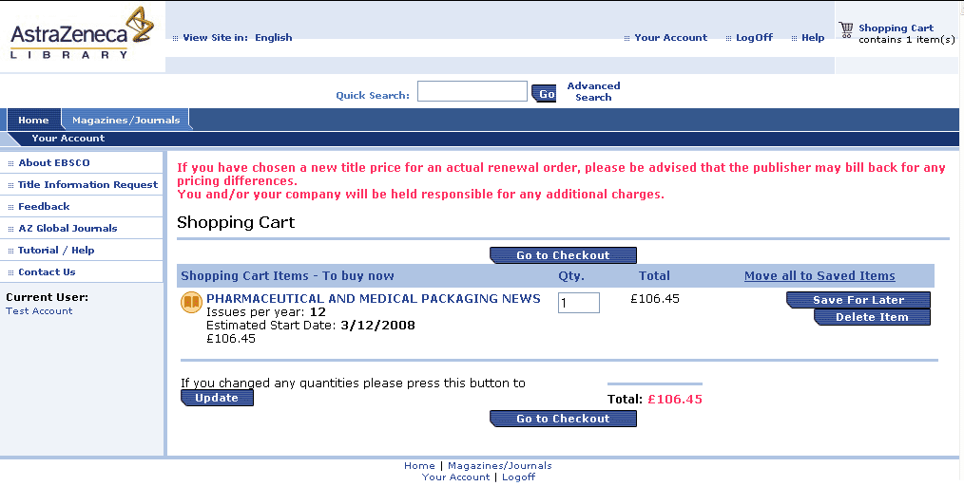

Note: New orders will have a start date calculated by the system.

Click Go to Checkout to complete checkout.

Step 5B: Add to Shopping Cart – Example of RENEWAL Subscription
- After selecting Renewal Subscription, click the Add to Shopping Cart button
- Once you have placed your items in the shopping cart, you need to review the cart.
- Renewal orders require you to input a date for the order to start and the subscriber number from a previous issue’s shipping label.

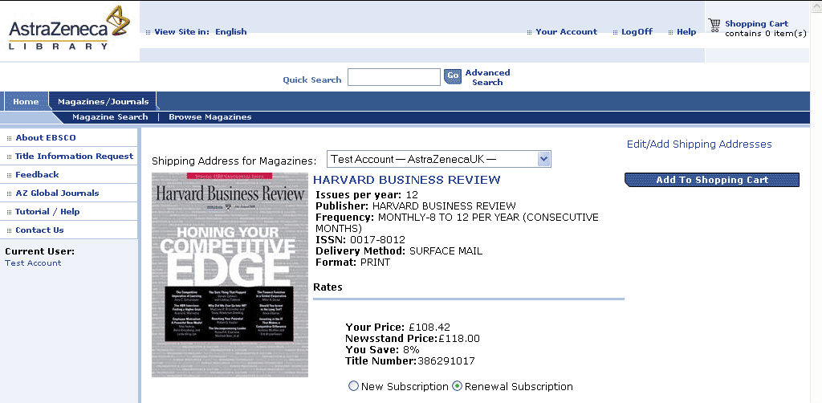
Select Renewal Subscription and Click Add to Shopping Cart.
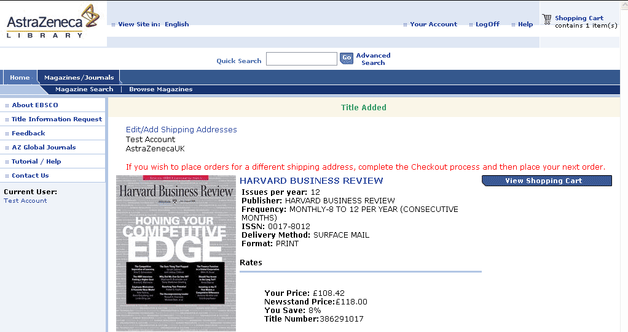
Click View Shopping Cart to review items.
To order on behalf of someone else, click on Edit/Add Shipping Addresses

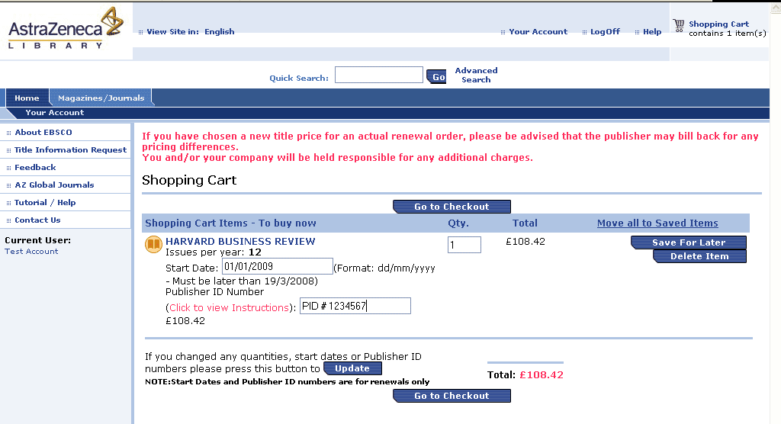
Enter Start Date for the renewal subscription.

Enter the Publisher ID Number found on the mailing label (not required).

Click on Update.

Go to Checkout.

Step 6: Complete Checkout
- Verify your order
- Click the Continue button

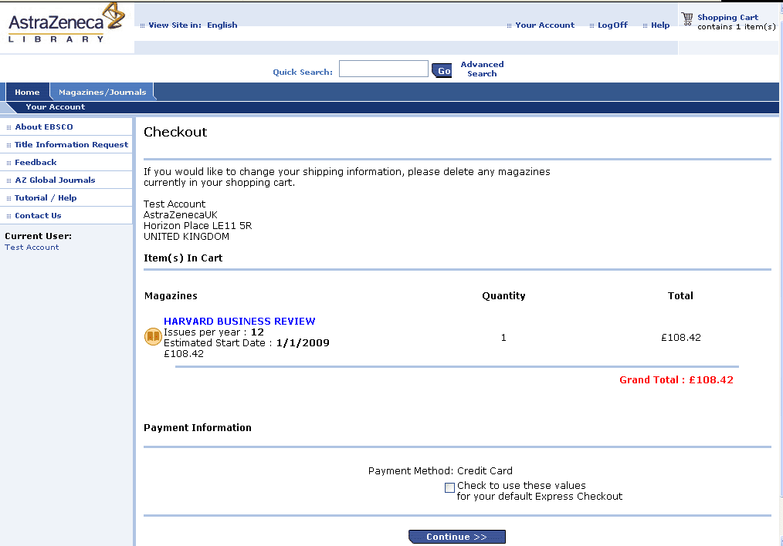

Step 7: Order Review
a. Click the Continue button

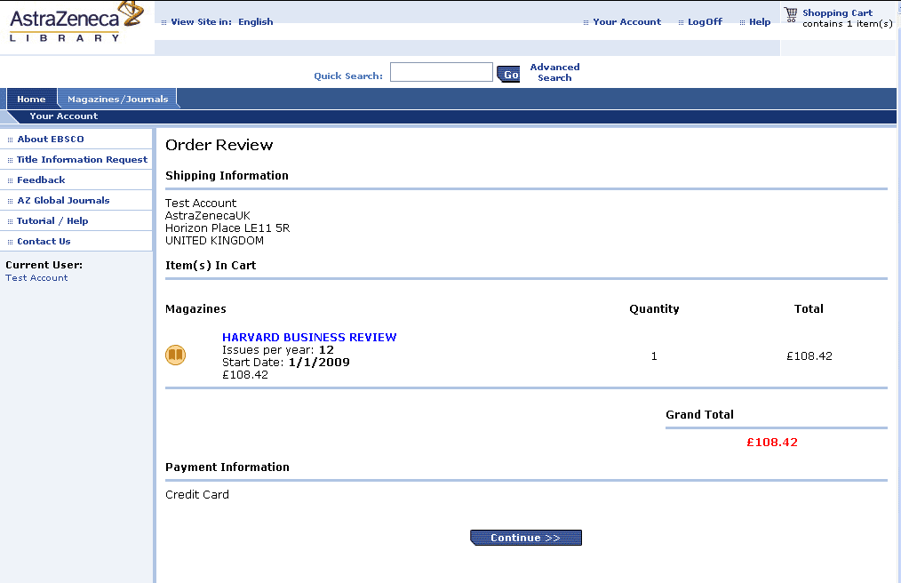

Step 8: Submit Order
a. Enter Credit Card information and submit order.

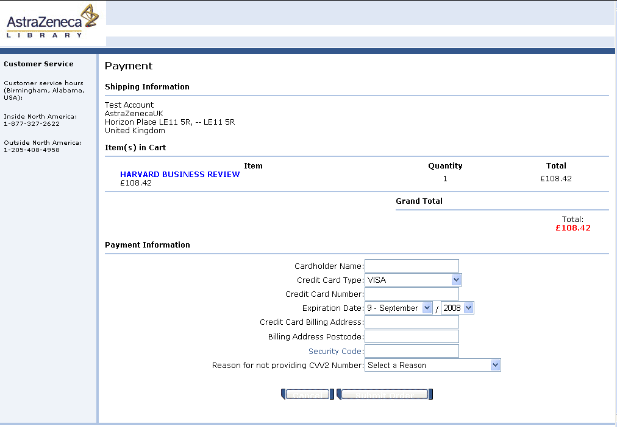

Step 9: Ordering on behalf of someone else
- Click on “Your Account”
- Edit Shipping Addresses
- Create New Address

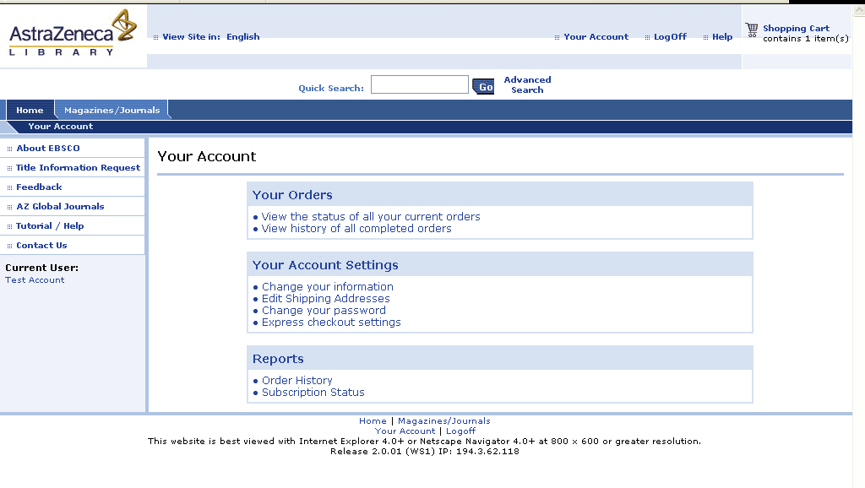
Setup new ship-to addresses to place an order on behalf of someone else.

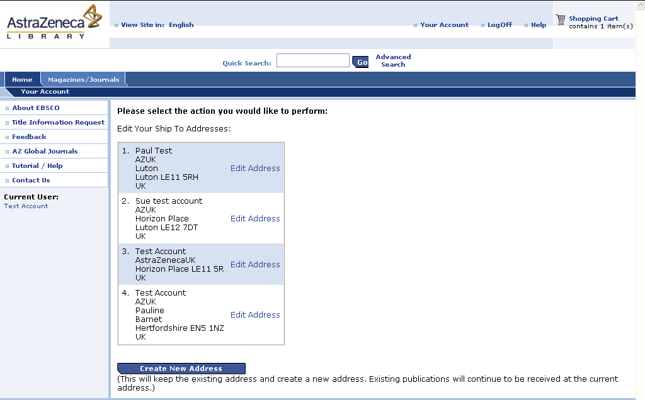
Click on Create New Address.

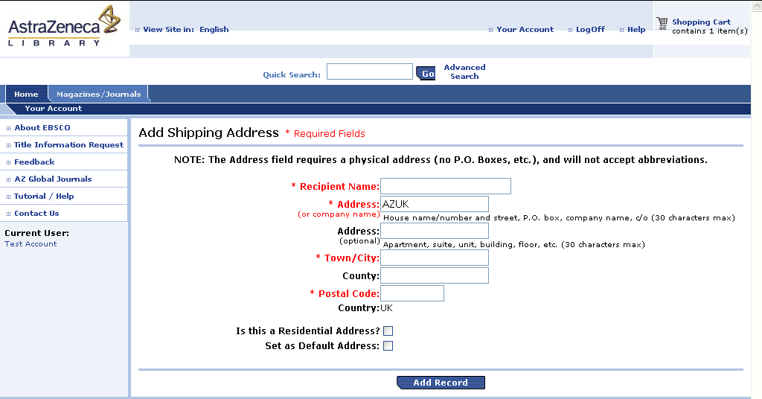
Enter address information for person you are ordering on behalf of.

