Customer Service Dept
2245 Delany Rd

Instructions Sheet – Mobile Board

MB3624, MB4836, MB6036 & MB7240
Waukegan, Il 60087
Ph: 847/244-1800‧800/323-4656
Fax:847/244-1818‧800/327-1698

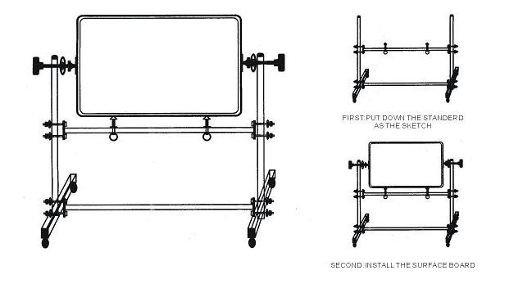
COMPONENTS LIST:

Two Side Board – 1pc
Leg Frame – 2pcs
Support Bar – 2pc
Knob – 2pcs
Machine screw 10 x 45MM – 8pcs
Magnetic – 4pcs

